Angular 4

Vocab

* Angular Modules: Collection of related ES6 Components. Ex: Checkout Page
* ES6 Component: Class using export keyword. Ex: Search Component on Checkout Page
* Directives
  + Custom Directives
    - Custom HTML Tags (like react components)
      * <mydirective></mydirective>
  + Built-In Directives
    - Structural Directives
    - Angular HTML attributes that modify the presentation of html
      * \*ngIf
        + Removes or recreates a portion of the DOM tree based on condition. If condition is false, the element and children are removed, if true a copy of element and children are inserted.
        + From BrowserModule.
      * \*ngFor
        + Repeats a portion of the DOM tree passing in data on each iteration.
* Service:
* Data binding
  + Interpolation
    - One way binding from the component class to the template (model to view).
    - Syntax {{variableName}} in the template. Looks for variableName in the corresponding component class.
* Template: HTML code

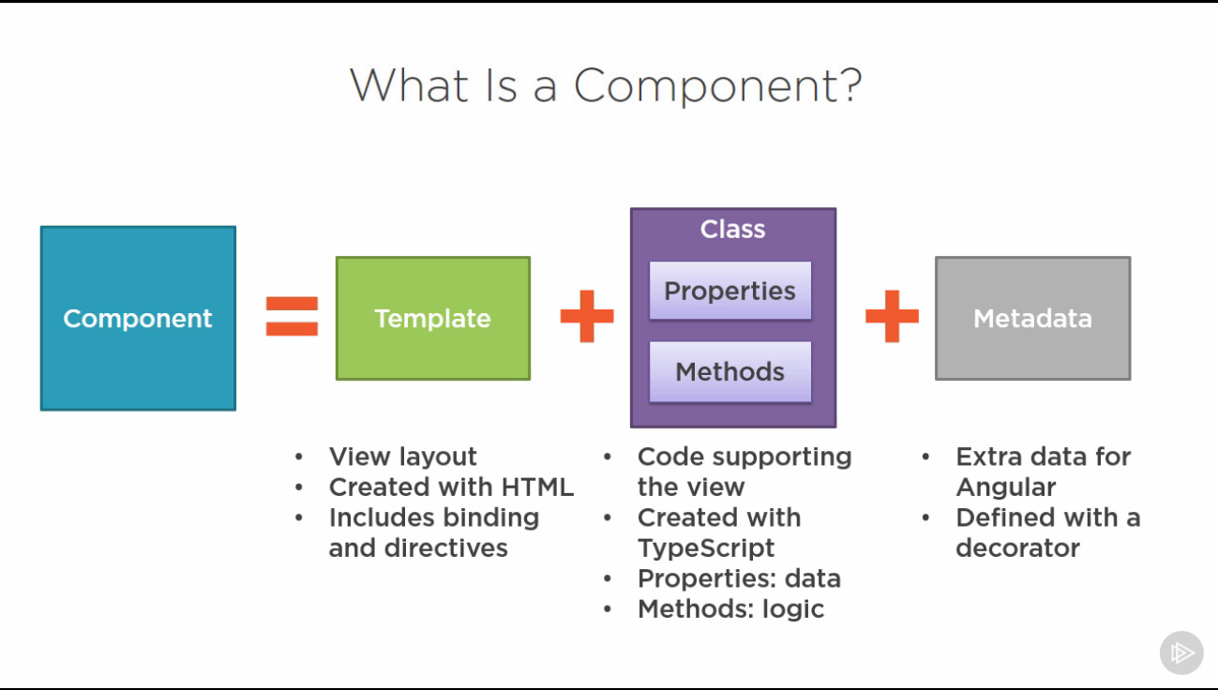

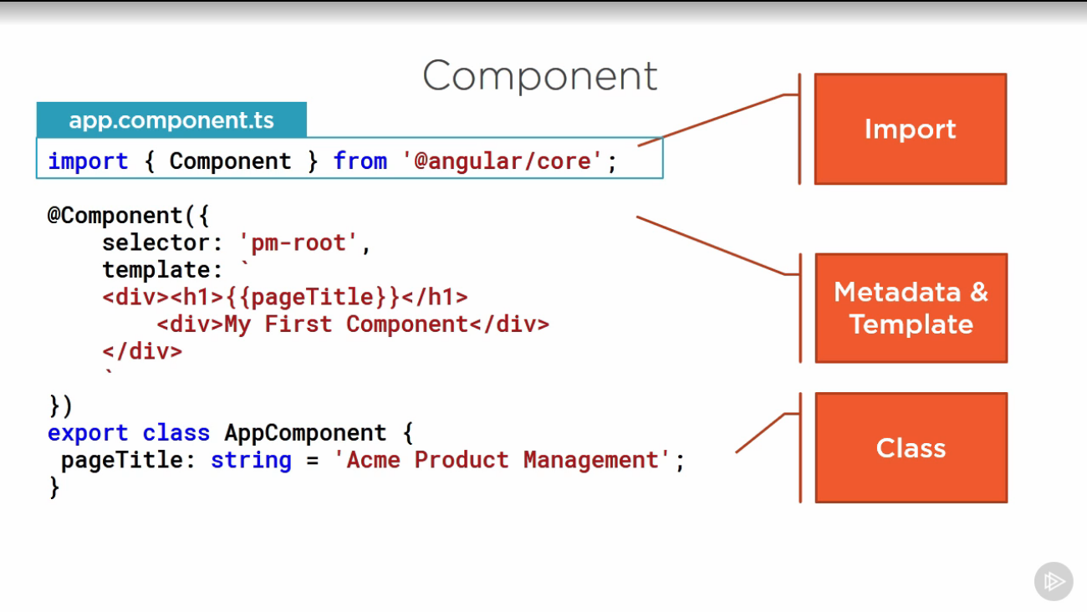

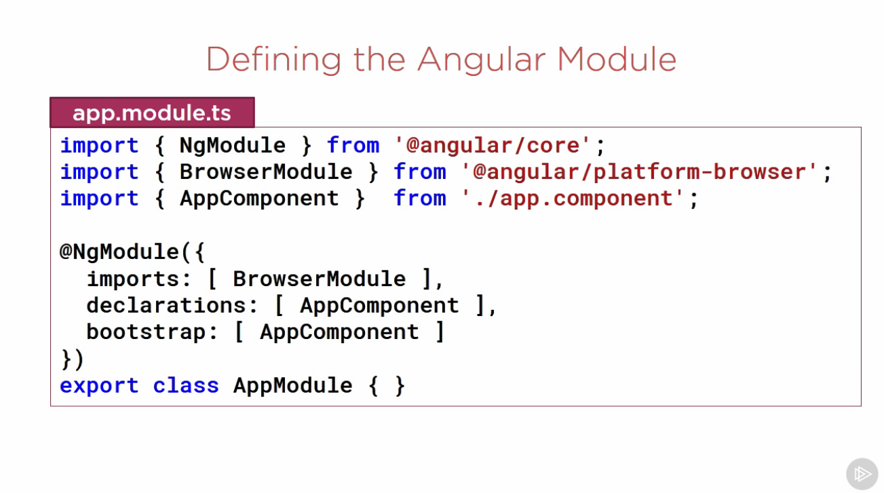

The first component to be loaded in the module. Should define selector

The ES6 Components that are in this Angular Module

The modules that this module depends on/uses

